**Early stage diabetes risk prediction**

This dataset contains the train and test files provided to you. The data contains the sign and symptoms of newly diabetic or would be diabetic patient. You need to build a model to predict upon the test data accurately.

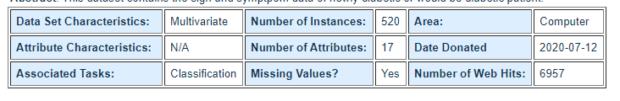

**Data Set Information:**

This has been collected using direct questionnaires from the patients of Sylhet Diabetes Hospital in Sylhet, Bangladesh and approved by a doctor.

**Attribute Information:**

Age 1.20-65  
Sex 1. Male, 2.Female  
Polyuria 1.Yes, 2.No.  
Polydipsia 1.Yes, 2.No.  
sudden weight loss 1.Yes, 2.No.  
weakness 1.Yes, 2.No.  
Polyphagia 1.Yes, 2.No.  
Genital thrush 1.Yes, 2.No.  
visual blurring 1.Yes, 2.No.  
Itching 1.Yes, 2.No.  
Irritability 1.Yes, 2.No.  
delayed healing 1.Yes, 2.No.  
partial paresis 1.Yes, 2.No.  
muscle stiffness 1.Yes, 2.No.  
Alopecia 1.Yes, 2.No.  
Obesity 1.Yes, 2.No.  
Class 1.Positive, 2.Negative.

For more details, you can check the following link:

https://archive.ics.uci.edu/ml/datasets/Early+stage+diabetes+risk+prediction+dataset.